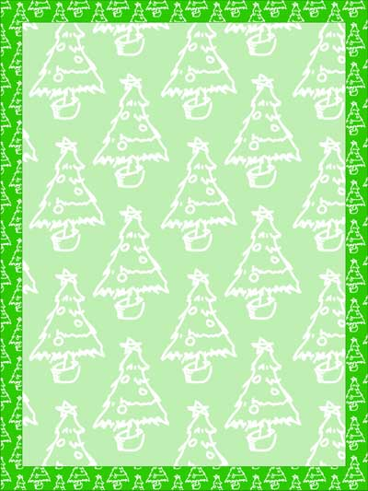

December 18, 2020

Kiʔsuʔk kyukyit k̓usmukusaⱡ ȼxamaⱡiⱡ ʔaki kiʔsuʔk kyukyit kukin makut!

The ʔaq̓am Administration staff and leadership would like to wish you all the very best for the holiday season. We hope that this season is full of happiness and laughter. Please remember to call and check on your loved ones who may sometimes struggle during this season.

This Christmas will look different to us all. To serve as a reminder, current restrictions include no social gatherings of any size with anyone other than your household or core bubble (such as
a partner or co-parent that lives in another household).

If you or anyone in your household inadvertently comes in contact with a person who has tested positive for COVID-19 or you are experiencing symptoms, feel free to contact our Registered Nurse, Dallas Cardinal for testing information. Alternatively, call 811 or book a test online at https://interiorhealthcovid.secureform.ca/index.php .

Christmas household gift cards have been delivered to homes on-reserve and mailed to others. If you card was not written on, note that the worth of each card is $100.

Christmas Mass will take place via Zoom this year – if you did not receive a link and want to participate, contact jgravelle@aqam.net.

Around the Community
Ecosystem enhancement contractors are planning to work throughout the holidays. This includes CHIL and Jaffray Logging as well as Akinmi, Nupqu, 7 Feathers, and Yates for brushing.

Housing renovation work will be continuing over the break; KD Electric, JJ Mechanical, and Silverado will be in community at homes that are currently receiving renovations.

Our office is closed for the break but we are just a call (or text) away.
-For general inquiries please contact Jodi Gravelle at 250-423-1877
-For health or wellness related inquiries please contact Dallas Cardinal at 250-250-919-4231
-For operations or housing related emergencies please contact Michelle Shortridge at 250-420-1083
-For school related inquiries please contact Eryn Geddes at 250-417-9941

Remember to be kind during this holiday season – ask for help if you need it and stay safe. We hope that 2021 brings us more opportunity for face-to-face services. We miss you!

Taxa,
JGravelle
Jodi Gravelle
Chief Administrative Officer

