For those who require a Status Card right away ʔaq̓am offers the Certificate of Indian Status (CIS) to be printed onsite. The CIS is a laminated paper status card which is valid for 5 years.

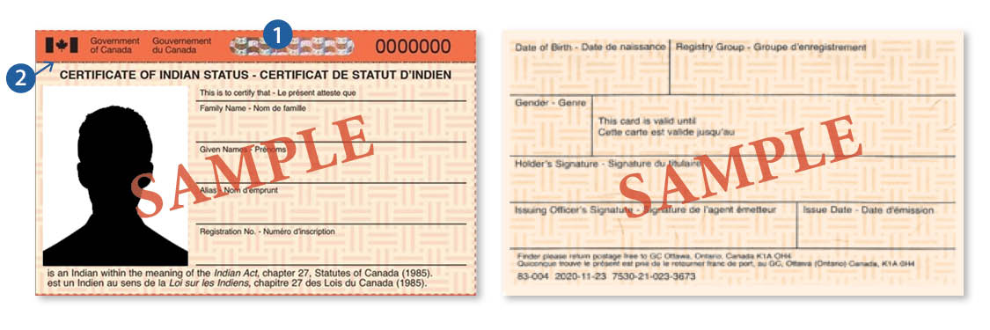

Assistance with completing the Secure Certificate of Indian Status (SCIS) application. Status Card application forms can be downloaded at <https://www.sac-isc.gc.ca/eng/1462806841047/1572461062751>

*Why your status card needs to be renewed?*

Like government-issued identity documents, for example, passport, driver's license, health card, your status card needs to be renewed to reflect your current appearance.